Development Documentation
Development Diary
Versions of the Program – You can Title each entry from today, Version 1.1, 1.2, 1.3 and so on
- Treat this like a Diary with each session being a different version.
- Walk me through how you built the software justifying decisions you made along the way
- Talk about errors that you encountered and issues that you had and how you solved these issues
- Use Screenshots
Overall Documentation of Code
What is included in the Prototype?
Models
- For each model- what is the model, why did you make it and how is it being used in the program.
- Explain and mention the language of the code
- Screenshot the code
Controllers
- For each controller – what is the controller, why did you make it and how is it being used in the program
- Explain and mention the logic of the code in key methods that are being used, what is that method doing, where is it redirecting it to
- If you have passed through a search string mention how it works
- Make sure to explain and reference specific lines of code, can annotate screenshots if you want
- Explain and mention the language of the code
- Screenshot the code
Views
- For each view- What is the view, why did you make that specific view and how is it linked with the controllers and models
- Explain the language being used and the content on the page
- Screenshot the Views, both code and output
Styling
- Screenshot you CSS and explain the styling options you put in place and why
- Mention that is CSS

Version 0.0.0
Created and set up the project using ASP.NET 9.0 MVC (model view controller) with individual accounts
Add Migration and update database upon first opening the project
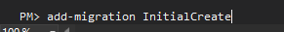
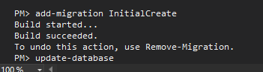
Created a Model Files that are filled with relevant data using the help of ClaudeAi
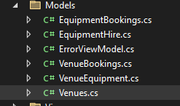
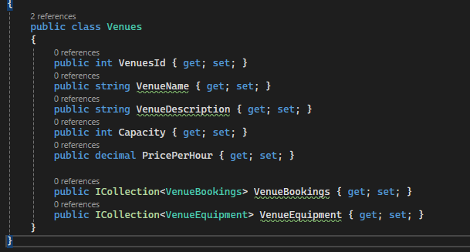
Venues Model Example
I will now scaffold each model one by one
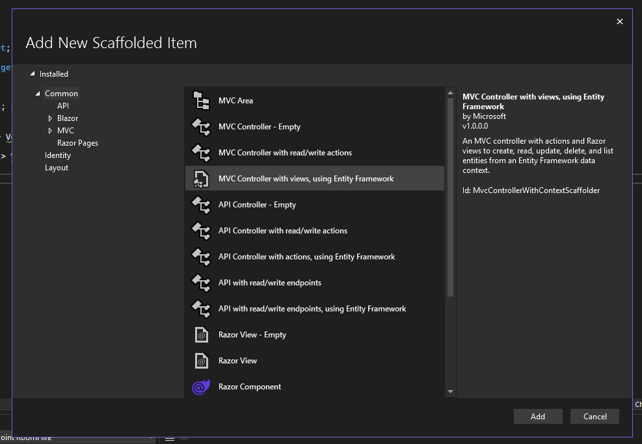
I will use MVC controller with Views, using Entity Framework
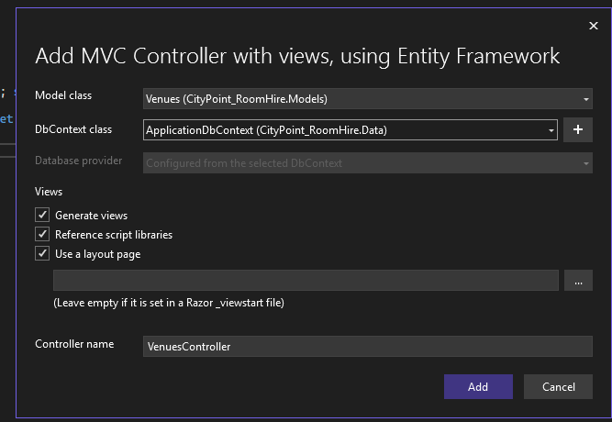
Then I will Select the model class for each model and the dbcontext and press Add
Then Add-migration and update database
I did stuff

